
PERFORMANCE ENGINEERED SYSTEMS

G2 INSTALLATION MANUAL

FOR RACING OR OFF ROAD USE

INTRODUCTION
PLEASE PURCHASE AUDI-ONLY POWER STEERING FLUID (PENTOSIN CHF 11S)
Please note this an older version, and doesn’t include the update for the new idler pulley which replaces the alternator pulley. The new manuals contain that procedure and it is straightforward.
Thank you for purchasing the PES G2 supercharger system. We have gone to great length to engineer this system to be a true bolt-on affair. Please read the entire instruction manual thoroughly before proceeding. If there is any part of the installation procedure that you are not comfortable with, please have a professional mechanic install the system.

PLEASE NOTE:
- The photos used in this manual were taken during the installation on a 2000 A4. There will be a special “NOTE” listed when there is a variation in the installation procedure.
- New PES supplied parts will be underlined in this manual.

PRE-INSTALLATION STEPS

Prior to installing the PES G2 supercharger system there are a few steps that are recommended to make the installation as safe and easy as possible.
- Make sure that the engine is completely cool.
- The car should not have been started for at least 2 hours to minimize any residual fuel pressure. This will reduce the fuel leakage that occurs while removing the fuel injectors.
- Remove the negative battery cable from the battery terminal before and during the installation procedure.
- Please save all parts and fasteners you remove from the car during installation. The system has been engineered so that the car may be returned to its stock configuration if so desired.

INSTALLATION

- Disconnect the negative battery terminal.
- Remove all plastic engine covers.
- Remove ECU and send it to PES for chip conversion. (See picture 1-3)

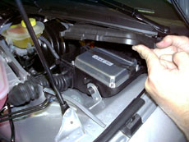
Picture 1
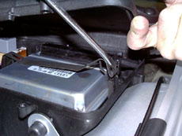
Picture 2
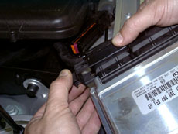
Picture 3

- Remove air box intake ducts.
(See picture 4-5)

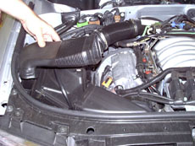
Picture 4

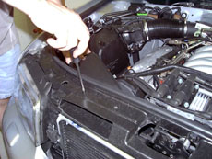
Picture 5

- Disconnect PCV tube from passenger side valve cover. (See picture THIS HOSE IS EXTREMELY FRAGILE, BE CAREFUL WITH IT NOT TO BREAK IT.

NOTE: On early 1998 models the crossover tube looks slightly different, and connects at the top front corner of each valve cover. Remove and set aside for now.

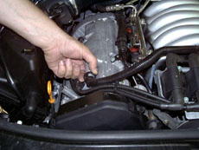
Picture 6

- Disconnect 6 spark plug wires from the coil pack. (See picture 7)
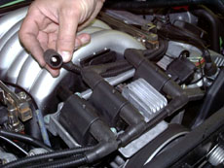
Picture 7

- Remove (4) bolts that hold coil pack in place. (See picture 8)
- Leave main electrical connector attached and move coil pack to the side.

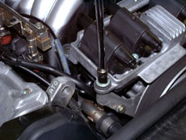
Picture 8

- Remove flexible air intake duct. (See picture 9)

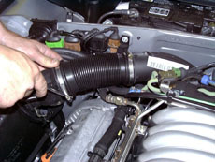
Picture 9

- Disconnect 2 vacuum lines from the right side solenoid. (See picture 10)
- Remove the 2 screws that hold the solenoid to the plastic mount, and move to the side.
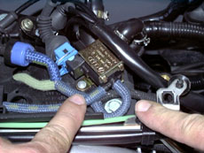
Picture 10
- Disconnect the intake air temp. sensor electrical connector. (See picture ) REATTACH THIS CONNECTOR WHEN FINISHED WITH INSTALL.

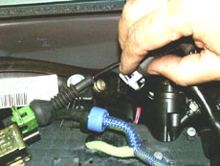
Picture 11

- Disconnect the left side solenoid electrical connector. (See picture 12)
- Remove the 2 screws that hold the solenoid to the plastic mount.

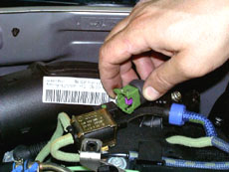
Picture 12

- Remove the 3 bolts that hold the plastic mount in place. (See picture 13)

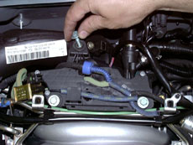
Picture 13

- Slide the plenum control hose out of position. (See picture 14)

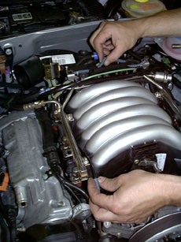
Picture 14

- Disconnect green hose from the “Y” connector. (See picture 15)

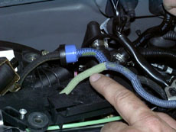
Picture 15

- Disconnect black hose from the “T” connector on the manifold. (See picture 16)

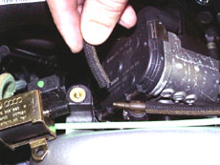
Picture 16

- Unclip the (6) fuel injector electrical connectors. (See picture 18)

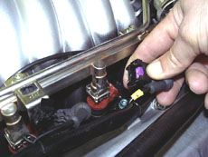
Picture 18

- Remove the (4) screws that hold the fuel rail in place. (See picture 19)

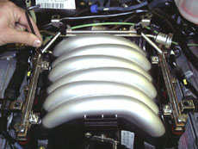
Picture 19

- Pull up on the fuel rail to dis-engage it from the intake manifold. (See picture 20)

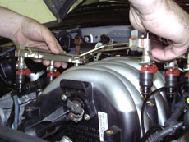
Picture 20

- Remove the injector-retaining clips as shown, and pull injectors out of fuel rail. (See picture 21)

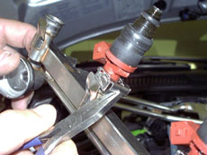
Picture 21

- Move fuel rail aside while still connected to fuel lines.
- Disconnect electrical connector from the throttle body. (See picture 22)

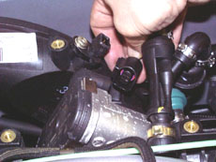
Picture 22

- Unplug the PCV tube from the intake tube. (See picture 23)
NOTE: On early 98 models this connector does not exist as pictured. You will need to disconnect a 5/16” hose as well as a smaller 1/8” hose at the bottom of the intake tube. The 1/8” hose barb on the intake tube will be capped.
.

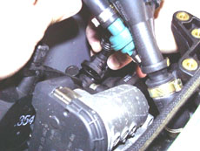
Picture 23

- Remove the screw holding the intake tube onto the throttle body with a hex wrench. Use a 10mm open-end wrench to prevent the center section from rotating. ALTERNATIVELY YOU CAN USE A HEX HEAD SOCKET (7mm I believe) which was easier for me. (See picture 24)

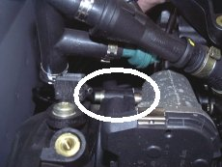
Picture 24

- Remove the intake tube and gasket from the throttle body. (See picture 25)
NOTE: On early 1998 models when removing the intake tube, you will also be unplugging the PCV tube. This plastic tube is plugged into the intake tube and retained with a clip.
First, remove the o-ring from the exposed end. Next, remove the retaining clip from the intake tube and pull out the plastic tube revealing another o-ring. Put this o-ring onto the PCV adapter and install it back into the intake tube with the retaining clip. The other o-ring will be used in a later step.(See picture 24A)

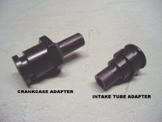
Picture 24A

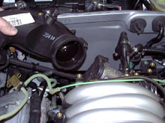
Picture 25

- Unbolt the (4) bolts holding the throttle body onto the manifold. See pic 25 for hole locations(See picture 26)
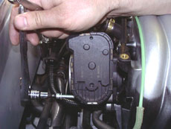
Picture 26
- Disconnect (2) rubber hoses from the rear of the intake manifold. One hose is low on the drivers side rear of the manifold (See picture 27). The brake booster hose is on the top rear of the manifold (See picture 28)

NOTE: Pre 2000 cars will only have the (top) brake booster hose. (See picture 28)

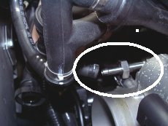
Picture 27

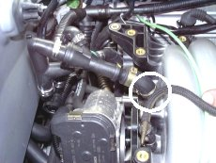
Picture 28

- Disconnect throttle cable Move the cable housing to full open throttle to allow slack in the cable to remove it.

- Remove the (2) 10 mm screws that hold the cruise control pot in position and move it aside.

- Remove the intake manifold by removing the (12) screws that hold it in place, and lift it straight up. BE CAREFUL NOT TO SNAP OFF THE PLASTIC ALIGNMENT PINS WHEN LIFTING STRAIGHT UP OR YOU WILL HAVE TO USE A DRILL AT LOW SPEED TO GET THEM OUT.(See picture 29)

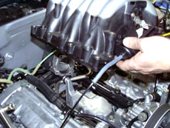
Picture 29

At this time exercise extreme caution not to let any objects drop into intake ports! I also used a vacuum to suck the intake ports clean as well.
- Remove 2 nylon manifold alignment pins. (See picture 30)

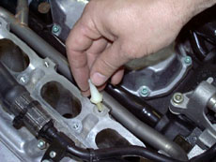
Picture 30

- Remove the (2) rubber seals from the bottom of the intake manifold and set aside for later use. (See picture 31)

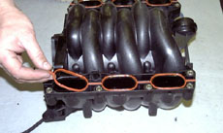
Picture 31
NOTE: On the earliest 1998 models Audi used the 1997 power steering pump. This pump is visually and dimensionally different from the one pictured in this manual. In this case you will need to replace the power steering pump, pulley, and high-pressure line. Call PES for more information.

- A. Loosen 3 power steering pulley bolts (See picture 32)
B. Remove serpentine belt.
C. Remove power steering pump pulley (3 bolts).

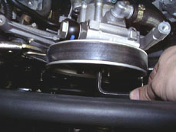
Picture 32

- Remove and replace the rubber power steering hose with the supplied part. (See picture 33)
BE CAREFUL NOT TO HAVE THIS HOSE KINKED OR FLUID WILL NOT FLOW.
NOTE: Only early 1998 models WILL NOT need to have the hose replaced.

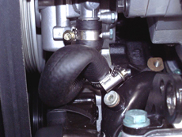
Picture 33

- Remove (6) bolts that hold the power steering pump/bracket to the engine block. (See picture 34)

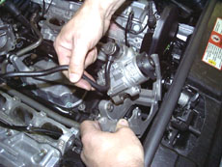
Picture 34

- Remove the bolt that secures the power steering high-pressure line to the valve cover. (See picture 35)

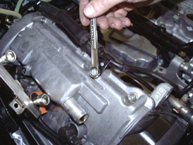
Picture 35
- Remove the screw holding the power steering pump bracket to the solid airline. (See picture USE A TIE WRAP TO SECURE THE SOLID AIRLINE

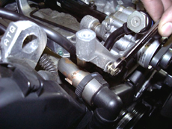
Picture 36

- The power steering pump bracket can now be completely removed. (See picture 34)
- Bolt power steering bracket to power steering pump using (2) 8x25mm hex bolts & washers. (See picture 37)

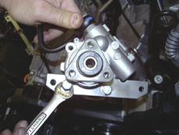
Picture 37

- The power steering pump can now be bolted into position using (2) 8x80mm hex bolts and washers and (2) spacers. (See picture 38). At the same time, the rear support should be bolted into position with (3) 8x20mm socket head cap screws. Be sure to tighten ALL FIVE bolts simultaneously. ATTACH THE REAR BRACKET FIRST. THE LOWER BOLT SHOULD GO IN FIRST AS IT HARD TO REACH ONCE BOLTED TO THE CAR. ALSO, A BALL HEAD ALLEN WRENCH REALLY HELPS HERE. (See picture 39)

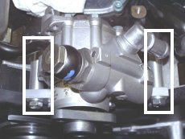
Picture 38

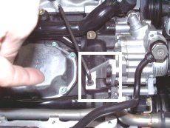
Picture 39

- The P/S high-pressure hose will need to be bent back into position and bolted back onto the valve cover. (See picture 40)

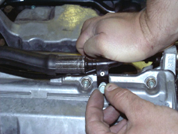
Picture 40

- Bolt the pulley back onto the P/S pump.
- NOTE: Step 46 ONLY applies to early 1998 models. Install the other o-ring retained from step 28 onto the crank vent adapter and insert into crankcase vent hole. Tighten the large nut while holding the main tube. This will expand and seal the o-ring in the hole.
- Take the rubber seals that were removed from the stock intake manifold in step 35 and insert them into the grooves on the new manifold. NOTE: In order to keep the seals from falling out during assy., put a small dab of grease in the grooves. (See picture 41)

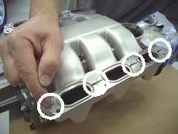
Picture 41

NOTE: Before proceeding to step 48, be sure that the mating surfaces are clean and unobstructed.

- Lower the supercharger/manifold assembly down onto the engine and secure it with (14) M6X30 socket head cap screws and washers. Tighten evenly in a crisscross pattern. Avoid over tightening. (See picture 42)

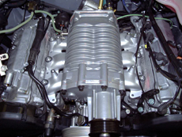
Picture 42

- Bolt the throttle body in position using the factory screws and a small amount of sealant. None was included in the kit, but I used small amount of Vaseline just to hold the gasket in place while I bolted the manifold down.
- On 2000-on (drive by wire) models use the factory spacer between the throttle body and manifold, using sealant on the side without the rubber seal. Do not over tighten. (See picture 43)

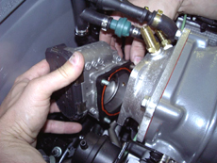
Picture 43
- Attach brake booster hose onto the brass hose barb. (See picture 44)

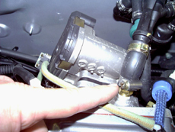
Picture 44

- Re-install throttle cable by feeding the cable through the hole in the cruise control mount bracket. (See picture 44A)

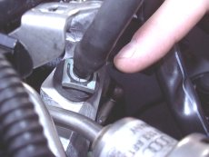
Picture 44A

Have an assistant hold the accelerator to the floor and adjust the length of the throttle cable so that the throttle body is opened fully without the cable binding or creating over tension on the throttle body. Adjust the throttle cable length by moving the retaining clip. (See picture 44A)

- Attach the cruise control pot onto the new cruise control mount bracket. (See picture 44B)

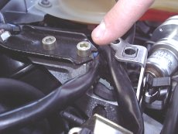
Picture 44B

- Re-attach the intake tube onto the throttle body. (See picture 45)
NOTE: Early 1998 models will install PCV connector hose at this time using (2) supplied hose clamps. (See picture 44C)

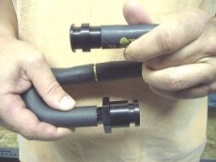
Picture 44C

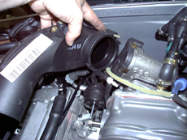
Picture 45

- Lubricate the o-rings of the (6) new fuel injectors using petroleum jelly. (See picture 46)

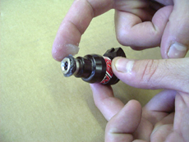
Picture 46

- Seat all 6 fuel injectors into manifold. Simply push down while twisting until fully engaged. (See picture 47)

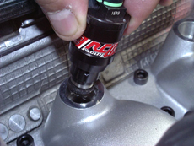
Picture 47
- Carefully line up the fuel rail with the tops of the (6) injectors. It is very important that all (6) cups on the fuel rail are lined up with the injectors. Make sure to position the electrical connectors on the injectors for ease of plugging connectors in. Misalignment can cause the o-ring to be pinched and cut. A fuel leak will result. Push down on the fuel rail until it is fully engaged with the injectors. (See picture 48)

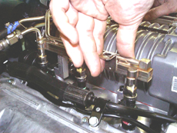
Picture 48

- Position (4) 2” long spacers between the fuel rail tabs and the bosses on the manifold. Line up the coil support brackets with the top of the fuel rail and secure them into place using (4) M6X70 hex head cap screws and washers. (See picture 49) The bolts will go through the coil support, fuel rail tabs, and the spacer and screw into the manifold.

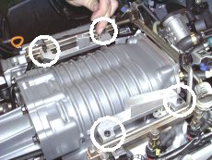
Picture 49

- Plug the (6) injector electrical connectors back in, as well as the throttle body electrical connector, intake air temp. sensor, and the left side solenoid electrical connector.
- Lubricate the o-rings on the PES fuel pressure regulator with petroleum jelly. Insert it into the fuel rail and replace the retaining clip.
- Trim the plastic outer sheath around the coil pack wires to allow it to move rearward. Be careful not to cut into the wires. (See picture 50)

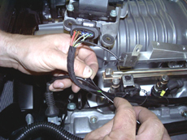
Picture 50

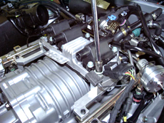
Picture 51

- Bolt the coil pack onto the brackets using the (3) factory screws. (See picture 51)
- Attach the fuel pressure regulator vacuum hose coming from the supplied hose on the left side of the supercharger.
- Re-attach the crankcase vent tube to passenger side valve cover. On older models re-attach the crossover tube.
- Remove #1 spark plug wire and re-label it as #3.
- Remove #3 spark plug wire and re-label it as #1. This is necessary for the wires to have the correct length. All other wires use their original numbers.
- Re-install the wires to their corresponding number on the coil pack. The numbers are cast into the coil pack bracket.
- Replace flexible intake duct.
- Install new belt. The belt configuration is the same as stock, except it runs over the supercharger pulley.
- Re-install the air box intake ducts.
- Tie wrap the left side solenoid to the fuel rail.
- Replace the plastic engine valve covers. The center cover will need extensive trimming to fit. Note, I don’t run any covers and that is better as it allows heat to escape from the engine easier.

- Re-install the ECU.
- Re-connect the negative battery terminal.
- Do a final inspection of all hoses, fittings, screws, and connectors.
- Be sure all tools have been removed from the engine compartment.

STARTING THE CAR
- First turn the key to the on position to verify that the “check engine” light comes on. In the rare instance that there is no “check engine” light present, do not attempt to start the car. Call PES if this occurs.
- When starting the car for the first time, you should have another person looking under the hood for fuel leaks or any other unforeseen problems.
- As a precaution, the observer should have a fire extinguisher nearby.
- Never touch the accelerator pedal before or during cranking the engine.

MAINTAINENCE
- USE ONLY SUPER UNLEADED FUEL (Minimum octane 92)
- Race fuel (100+octane) should be used on track days.
- The Eaton SC is internally lubricated with a special synthetic lubricant developed by Eaton. The SC oil level should be checked every 7000 miles. To check the oil level, simply remove the oil plug on the front of the SC unit. The oil should be just at the bottom of the oil fill hole. USE ONLY EATON LUBRICANT WHEN ADDING OIL. OTHER OILS WILL DAMAGE THE UNIT AND VOID THE WARRANTY. I have posted Eaton part #s on my site you can get from any GM or Ford dealer.

- Change your engine oil every 3000 miles.
- Regularly inspect the fasteners for tightness.
- Periodically inspect the serpentine belt for wear.
- Avoid turning and holding the steering wheel to full lock. This may cause belt slippage.
- PES recommends using a spark plug one(1) heat range colder than stock in geographic areas with very high temperatures, or when the car will be driven on the track.

CONCLUSION

We hope that you enjoy your new PES supercharger system. If you have any questions please call us toll free at 877-697-1688 or 908-806-8426.

We greatly appreciate your business!

PES LIMITED WARRANTY

THE WARRANTY
The original purchaser of the PES Racing & Off Road supercharger system is warranted against defective materials and workmanship for one year from date of purchase with unlimited mileage.
WHAT VOIDS THE WARRANTY
- Incorrect installation and/or maintenance: The PES supercharger system must be installed and maintained as per the prescribed routine maintenance procedure as outlined in the installation guide.
- No proof of purchase: At the time of a warranty claim, buyer must provide proof of purchase (original receipt or invoice).
- Incorrect use: Any damaged, abused, or modified supercharger units or system parts will not be warranted.
EXTENT OF WARRANTY
Any defective part properly returned to PES will be replaced by PES. PES will not be responsible for any other expenses incurred by the customer under the terms of this warranty, nor shall it be responsible for any damages either consequential, special, contingent, or otherwise; or expenses or injury from the installation or use of the supercharger system. Any parts returned to PES shall be sent at the customer's expense along with a proof of purchase. PES reserves the right to determine whether the terms of the warranty, set out above, have been properly complied with. In the event that the terms are not complied with, PES shall be under no obligation to honor this warranty.

